*Florida International University*

*School of Computing and Information Sciences*

Software Engineering Focus

Feature Document

User Story ID <801>

**Name: Mairim Barrios**

**Team Member(s):**

**Project: AR-VR-VE For CS Education**

**Product Owner(s)**: Francisco Ortega

**Mentor(s)**:

**Instructor**: Masoud Sadjadi

**User Story Name: Spawn user instructions upon button click**

* Description: As a user I want to click on the command I wish to issue and have it pop up on the command holder so that I can run it and move my character

Acceptance Criteria

* User sees button with an abbreviation of the command
* Upon user click of the button the command appears in the solution panel
* The command in the solution panel demonstrates a hint of OOP

**Use Case**

* Name: Player has seen the maze and is ready to choose a command to move the character
* Actor: Player
* Preconditions: Began playing the level and has seen the maze
* Description <The player begun playing the level, after seeing the maze the player is ready to build an instruction set for his/her solution by clicking on the command buttons>:

**Use Case Diagram**

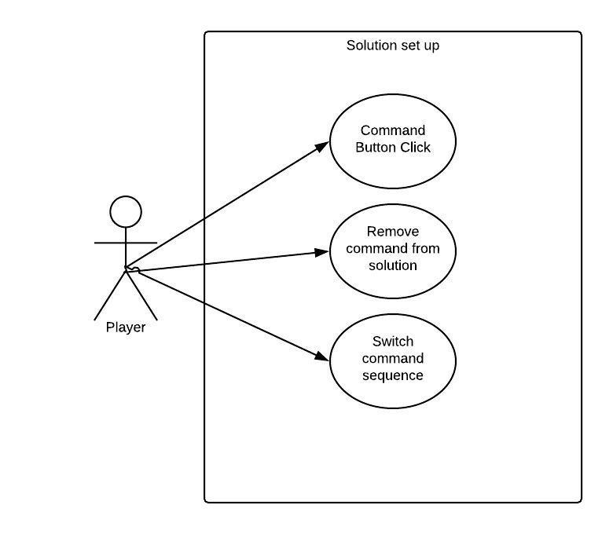

**Sequence Diagram**

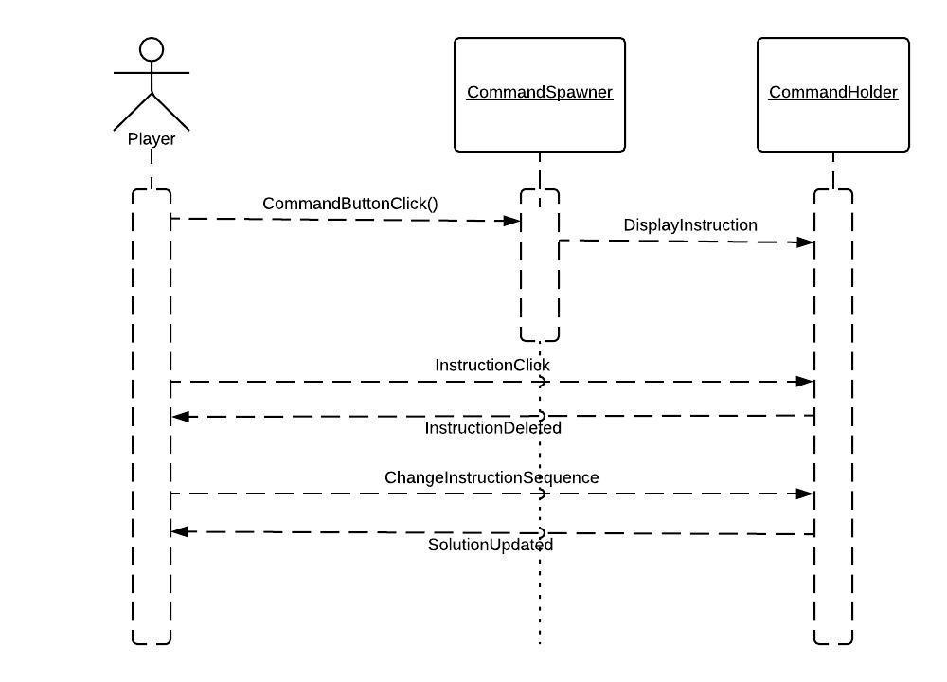

**Class Diagram**

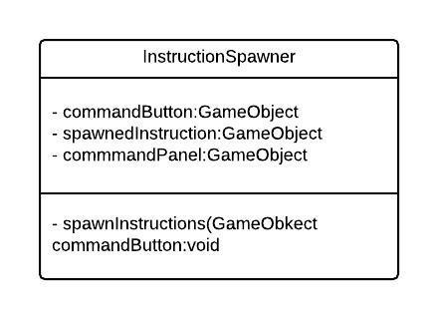

**Unit Test**

* Test case ID:
* Description/Summary of Test:
* Pre-condition:
* Expected Results:
* Actual Result:
* Status (Fail/Pass):

**Integration Test**

**Visual User Guide** <like one or two screenshots of the feature. For the hardware project, a photo of device is required>